Title: Braintree Payment Integration Component for Liferay7

**Braintree Payment Integration Component**

🡪This component provides an ability to connect braintree payment gateway integration with Liferay 7.

🡪Braintree provides the global commerce tools that are required to build businesses, accept payments, and enable commerce into the applications. It is the simplest way to get paid for your great ideas -- across any device, and through almost any payment method.

🡪Merchants in more than 40 countries worldwide can accept, split, and enable payments in more than 130 currencies using Braintree. It emphasizes its easy integrations, multiple payment method options (including PayPal and Venmo), simple pricing, security, and support.

🡪We have considered credit card payment method for this component. It contains two different modules such as JSP Module and Service Module**.**

**[1] JSP Module**

JSP Module accommodates the relevant pages to create:

* Customer
* Submerchant
* Liferay User as Customer
* Liferay User as Submerchant
* Customer List
* Submerchant List
* Payment Page

Please note: If you have decided to create your own JSP pages, you can create it. In that case, you just need to deploy the Service Module and call the services from your own jsps.

**[2] Service Module**

Service Module accommodates services such as:

1) Create Transaction

2) Cancel Transaction

3) Search Transaction By Customer ID

4) Search Transaction By Transaction ID

5) Create SubMerchant

6) Find SubMerchant

7) Search SubMerchant

8) Update SubMerchant

9) Create Liferay User as SubMerchant

10)Submerchants List

11) Create Customer

12) Update Customer

13) Create Liferay user a Customer

14) Delete Customer

15) Customers list

16) Find Customer

17) Search Customer

18) Liferay Active Users list

**How to implement Braintree Payment Integration Component?**

To implement this ready to use Braintree Payment Integration Component you need to follow the following simple steps.

* **Create Braintree Sandbox account**

1. Go to [**https://sandbox.braintreegateway.com**](https://sandbox.braintreegateway.com/)
2. Create Braintree merchant account in sandbox.

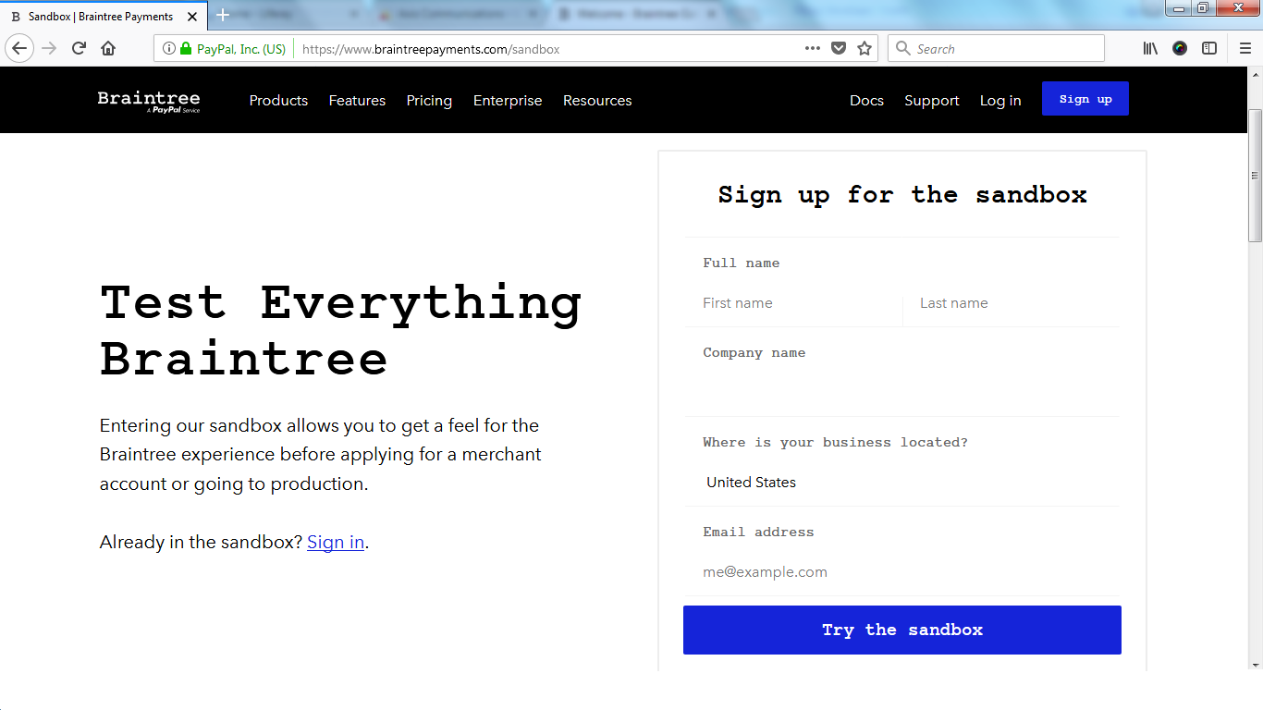

1. Copy merchant account keys(Environment,MerchantID,Private Key,Public Key).
2. If you don't want to use default merchant account, then create new master merchant account by selecting 'Make this my default merchant account'.

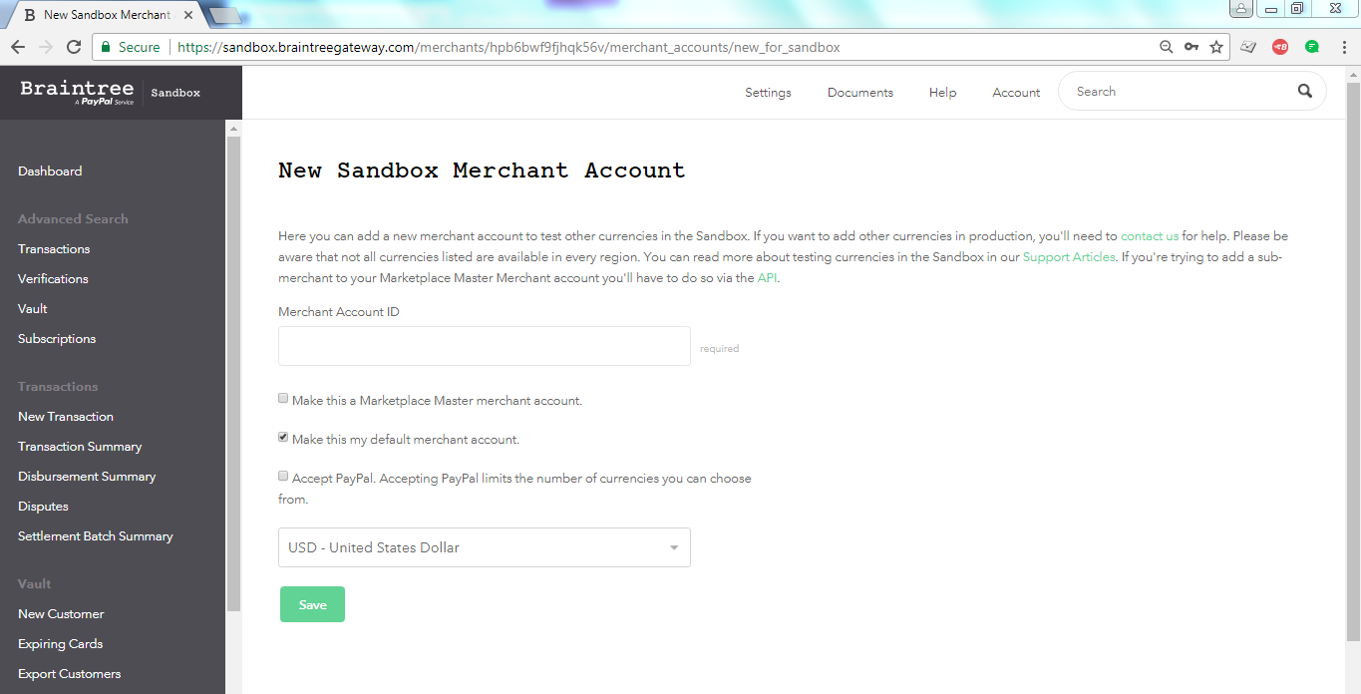

1. You can see list of customer details from Vault->select start and end date->search.

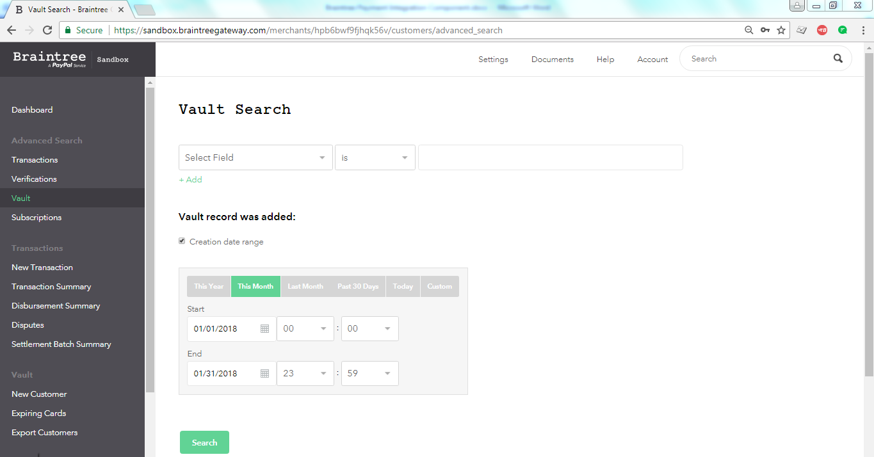

1. You can see list of merchant details from Account->Merchant account info->View all merchant accounts.

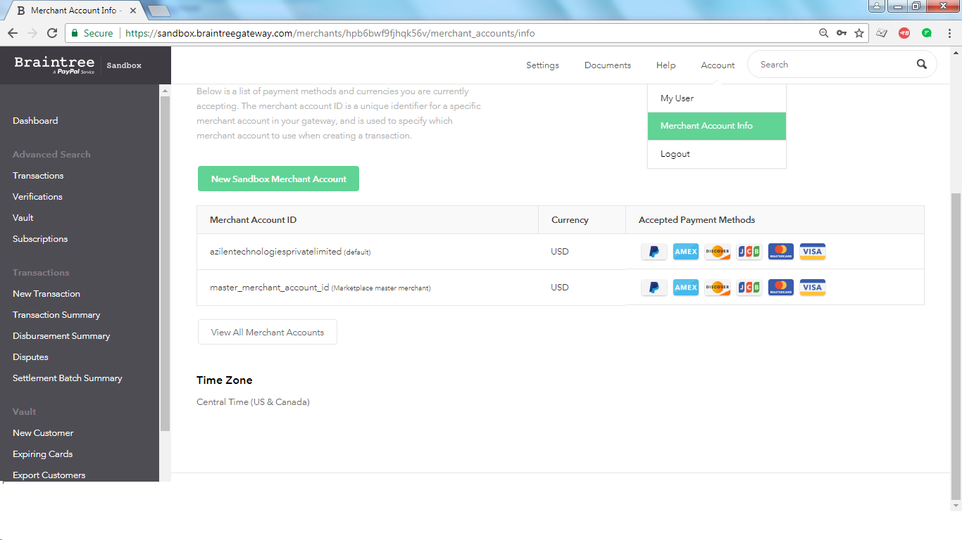

1. You can see list of transactions from Transactions->Select start and end date->Search.

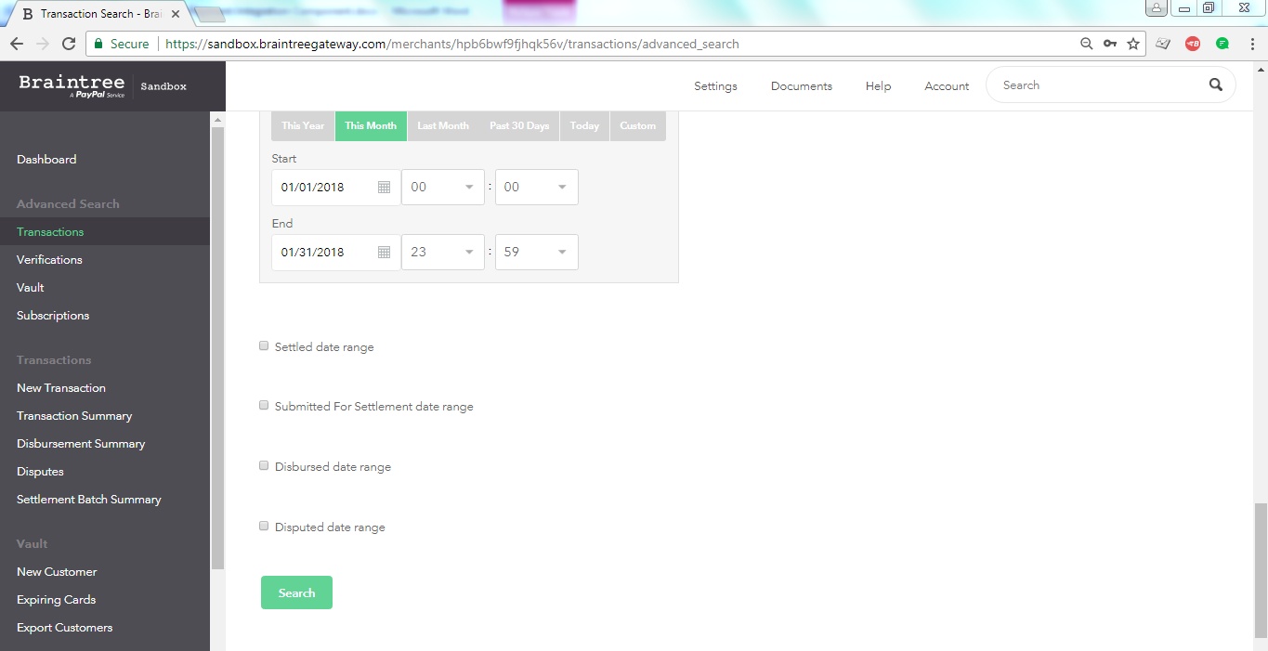

* **Deploy application jar files**

1. Download jar files for braintree Jsp module and service module from marketplace.
2. REST API Settings
   1. Control Panel->System Settings->Foundation->REST Extenders
      1. Add new configuration
      2. Context paths:-/rest
   2. Control Panel->System Settings->Foundation->CXF Endpoints
      1. Add Entry
      2. Context path:-/rest
3. Put below properties of merchant account keys in portal-ext.properties

* BT_ENVIRONMENT
* BT_MERCHANT_ID
* BT_PUBLIC_KEY
* BT_PRIVATE_KEY

1. Put Jar files for braintree_payment_integration and braintree-payment-rest-api modules in deploy folder of your liferay7 server.
2. Restart server.
3. Application is deployed successfully. you can use it as per your requirement.
4. Set service fee amount from braintree_payment_integration portlet configuration page.

**Services:-**

1. **/o/rest/payment/braintree/transaction/searchByCustomer/{customerId}**

Parameter:-customerID

Response:-Json

1. **/o/rest/payment/braintree/transaction/search/{transactionID}**

Parameter:-transactionID

Response:-Json

1. **/o/rest/payment/braintree/transaction/cancel/{transactionID}**

If transaction is in SETTELED state then it will be refunded,otherwise it will be cancelled.

Parameter:-transactionID

Response:-Json

1. **/o/rest/payment/braintree** **/merchant/search/{emailAddress}**

Parameter:-merchant emailAddress

Response:-Json

1. **/o/rest/payment/braintree/merchant/find/{merchantID}**

Parameter:-merchant ID

Response:-Json

1. **/o/rest/payment/braintree** **/customer/find/{customerID}**

Parameter:-customer ID

Response:-Json

1. **/o/rest/payment/braintree/customer/search/{emailAddress}{firstName}**

Parameter:-emailAddress(required),firstName(optional)

Response:-json